**Homework 4**

Remember that your programs must read the data from the text files exactly as they appear. You may not edit the text files to make them more convenient for SAS. Turn in the code, log file and output. If any of these 3 items is missing then you will not be graded for that question. Use the snipping tool instead of screen shots and make sure the font is large enough for me to read.

1. Refer to the SOCCER dataset. Write a SAS program which creates a SAS dataset and writes each player’s name and jersey number to a text file called SOCCDATA.TXT on your USB. The text file should look like this:

Danielle Bass wears Number 11 .

Erin Baxter wears Number 23 .

Keisha Bell wears Number 5 .

Christie Brady wears Number 8 .

Etc.

Turn in a copy of the SAS program and a printout of the file SOCCDATA.TXT. Make sure that your program reads jersey number 00 correctly.

**CODE**

**data** soccer;

informat lastname $13.;

infile '\\Client\C$\Users\Ultron\Desktop\ISM6930 SAS\Lesson 4\Homework\soccer.txt';

input number $ firstname $ lastname $ code $ value $ level $ value2 $;

**run**;

**data** _null_;

set soccer;

file '\\Client\C$\Users\Ultron\Desktop\SOCCDATA.txt';

put firstname lastname 'wears Number ' number **2.**' .';

**run**;

**LOG**

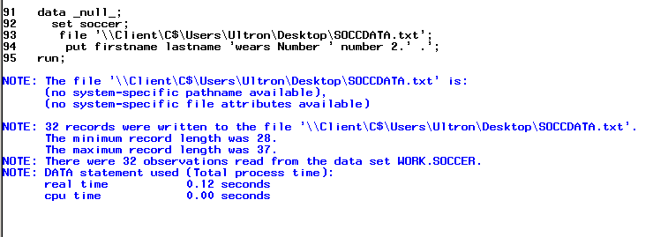

**OUTPUT**

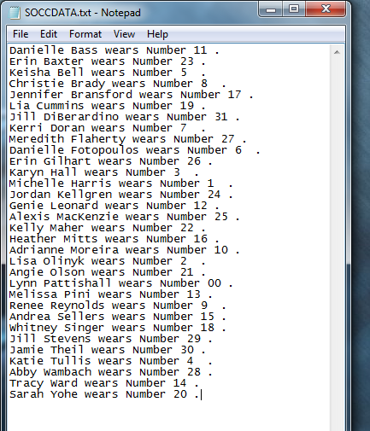

1. Refer to HOCKEY dataset. Write a SAS program which creates a SAS dataset and writes the date, Ohio State’s score, opponent’s name and the opponent’s score to a text file called HCKYDATA.TXT on your USB. Use an appropriate format for the date. The text file should look like this:

10/10/1997: Ohio State 5 , Toronto 0

10/18/1997: Ohio State 0 , Miami 3

10/24/1997: Ohio State 2 , Merrimack 7

10/26/1997: Ohio State 5 , Merrimack 3

Etc.

**CODE**

**data** hockey;

infile '\\Client\C$\Users\Ultron\Desktop\ISM6930 SAS\Lesson 3\Homework\hockey.csv'

dlm=',' firstobs=**2** dsd;

input Date :$10. Team :$20. City :$20. State :$15. OSU OPP ;

**run**;

**data** _null_;

set hockey;

file '\\Client\C$\Users\Ultron\Desktop\HCKYDATA.txt';

put date MMDDYYY. @**11** ':' @**13**'Ohio State ' OSU ' ,' team opp ;

**run**;

**LOG**

**OUTPUT**

1. Refer to the MANATEES dataset. Write a SAS program which reads and prints the dataset. Provide labels for all of the variables, and print the dataset with the columns headed by those labels. Add a title and a footnote to the printout. Write at least one comment statement in your program.

**CODE**

**data** manatees;

*manatees are cool;

infile '\\Client\C$\Users\Ultron\Desktop\ISM6930 SAS\Lesson 4\Homework\manatees.txt' dlm='09'x firstobs = **2**;

input Year Waterc Lock Relat Perin Natur Undet;

label waterc='1' lock='2' relat='3' perin='4' natur='5' undet='6';

**run**;

**proc** **print** data = manatees LABEL;

title 'Manatees';

footnote 'footnote';

**run**;

**LOG**

**OUTPUT**

1. Refer to the USEDCARS dataset. Write a SAS program which reads the dataset and prints only the following information in this order:

* Year
* Manufacturer
* Model
* Mileage (printed as “<50,000”,”>=50,000”, or “Unknown”, depending on the numeric value of the mileage variable)
* Cost (printed as “Economy” if the price is under $5,000, “Moderate” if the price is between $5,000 and $10,000, or “Expensive” if the price is over $10,000).

Use FORMAT statements to print the mileage and cost variables. Write at least one comment statement in your program.

**CODE**

**LOG**

**OUTPUT**

1. Refer to CATS2 dataset. Write a SAS program which reads the dataset and prints only the names of the cats and their GFR values at week 0, arranged in order from the smallest GFR value at week 0 to the largest. Write at least one comment statement in your program.

**CODE**

**LOG**

**OUTPUT**

1. Refer to the HANKS dataset. Write a SAS program which reads the dataset and prints (in chronological order from 1984 to 1998) only the title of the movie, the year, and the simplified children’s rating system, as described below:

* MPAA rating of G = ”Suitable”
* PG or PG-13 = ”Questionable”
* R = ”Not Suitable”

Use FORMAT statements to print the ratings. Write at least one comment statement in your program.

**CODE**

**LOG**

**OUTPUT**

1. Refer to the IRIS dataset. Write a SAS program which reads the dataset and prints only the data for the 50 observations with the largest sepal widths. Label the variables and print those labels instead of the variable names. Write at least one comment statement in your program. (You should see from the printout that *setosa* tends to have the largest sepal widths.)

**CODE**

**LOG**

**OUTPUT**

1. Refer to RYAN dataset. Write a SAS program which reads and prints the dataset. Now, run the same program, but insert these lines as the first two lines of the program:

options pageno=385 missing=’?’ skip=20 firstobs=5 obs=12;

run;

Compare the two results and write an explanation of the functions performed by each of the five options. Turn in a copy of your SAS program statements, the “before” and “after” printouts, and your written explanations.

Note-To return your SAS session back to its normal options, submit the following two lines of SAS code:

options pageno=1 missing=’.’ skip=0 firstobs=1 obs=MAX;

run;

**CODE**

**LOG**

**OUTPUT**

1. Run the following program to create a SAS data set called Colors

**data** colors;

input Color : $1. @@;

datalines;

R R B G Y Y . . B G R B G Y P O O V V B

;

Use a format to group the colors as follows:

R, G, B = Group 1

Y, O = Group 2

Missing = Not Given

All others = Group 3

Use PROC FREQ to list the frequencies of the color groups.

**CODE**

**LOG**

**OUTPUT**

1. Write the necessary statements to make three permanent formats in a library of your choice. Use the FMTLIB option to list each of these formats. The formats are defined as follows:

YESNO 1=Yes, 0=No

$YESNO Y=Yes, N=No

$Gender M=Male, F=Female

Age20yr low-20 = 1, 21-40=2, 41-60=3, 61-80=4, 81-high=5.

**CODE**

**LOG**

**OUTPUT**